Technical Documentation — FEMA Disaster Dashboard
📦 Data Sources
Primary datasets used:
- us_disaster_declarations.csv — full FEMA declaration history
- us_disasters_m5.csv — filtered subset for modelling validation
Imported using Power BI Power Query.

🧹 Data Cleaning — Power Query Steps
Performed in Power Query Editor:
Steps for Data Cleaning
- Split date format column into date and time
- Check and remove blank values or missing values
- Change type of fips column to text
- Add custom column – use formula –“ Text.Length(Text.Trim([fips]))”
- Filter the custom fips column to 5
- Change back the fips column to whole number
- Filtered null values and removed duplicates
- Handled malformed and missing FEMA date fields using defensive Power Query transformations to ensure reliable model refresh. – opened advanced editor in home tab then added this code in the end
#"Safe Date Conversion" =
Table.TransformColumns(
#"Promoted Headers",
{
{"incident_begin_date", each try Date.From(DateTime.FromText(_)) otherwise null, type date},
{"incident_end_date", each try Date.From(DateTime.FromText(_)) otherwise null, type date},
{"disaster_closeout_date", each try Date.From(DateTime.FromText(_)) otherwise null, type date},
{"declaration_date", each try Date.From(DateTime.FromText(_)) otherwise null, type date}
}
)
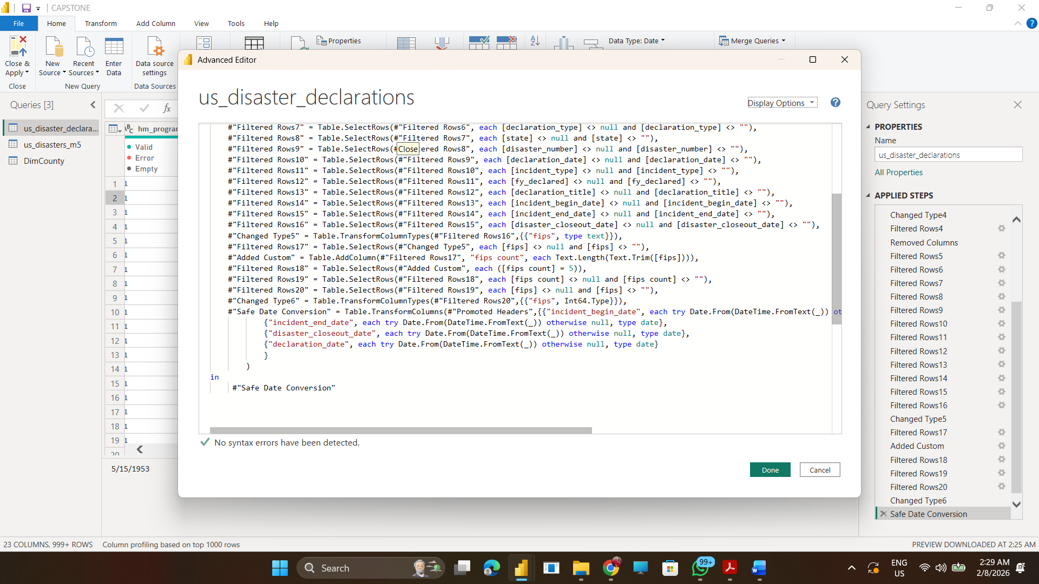
- Close and apply

🧱 Data Model — Star Schema
Fact Table
- Disaster_Declarations (central fact)
Dimension Tables
- DimDate
- US_States_and_Territories
- Incident Type dimension
- Program indicators
Relationships:
- DimDate → Fact (declaration_date)
- State → Fact (state)
- Incident Type → Fact (incident_type)
Model built using one-to-many relationships.

🗂 ERD (Entity Relationship Diagram)
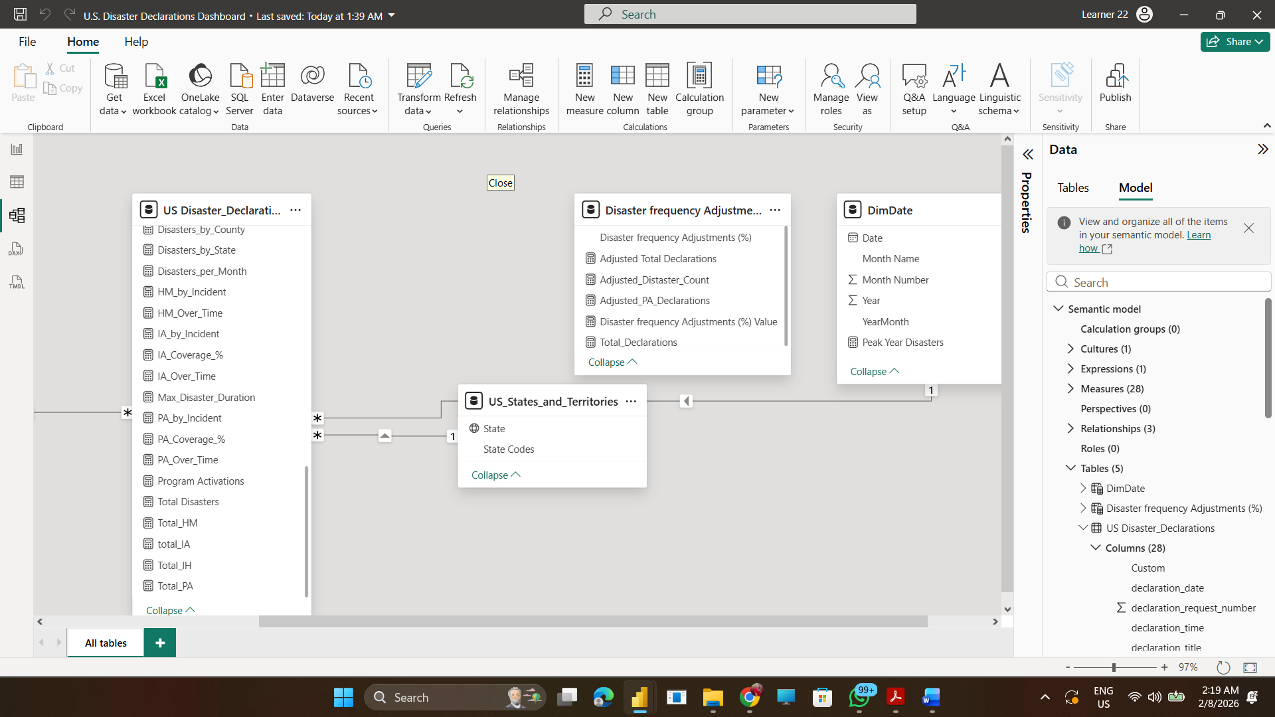

📐 DAX Measures Used in Dashboard
1. DimDate =
ADDCOLUMNS (
CALENDAR ( DATE(1953,1,1), DATE(2025,12,31) ),
"Year", YEAR([Date]),
"Month Number", MONTH([Date]),
"Month Name", FORMAT([Date], "MMM"),
"YearMonth", FORMAT([Date], "YYYY-MM")
)
2. Disaster frequency Adjustments (%) = GENERATESERIES(-0.2, 0.2, 0.2)
3. Adjusted Total Declarations = [Program Activations]*(1+'Disaster frequency Adjustments (%)'[Disaster frequency Adjustments (%) Value])
4. Adjusted_Disaster_Count = [Total Disasters]*(1+'Disaster frequency Adjustments (%)'[Disaster frequency Adjustments (%) Value])
Purpose: What-If scenario adjusted disaster count
Used in: Scenario Planning page
5. Adjusted_PA_Declarations = [Total_PA]*(1+'Disaster frequency Adjustments (%)'[Disaster frequency Adjustments (%) Value])
6. Disaster frequency Adjustments (%) Value = SELECTEDVALUE('Disaster frequency Adjustments (%)'[Disaster frequency Adjustments (%)], 0)
7. Total_Declarations = [Total_HM]+[total_IA]+[Total_PA]+[Total_IH]
Or
Program Activations = [Total_HM]+[total_IA]+[Total_PA]+[Total_IH]
Purpose: Counts how many recovery programs were activated
Used in: Overview + Temporal Trends dual axis chart
8. Average_Disaster_Duration = AVERAGE('US Disaster_Declarations'[Disaster_Duration])
Purpose: Calculates average duration in days
Used in: Overview KPI + Incident Analysis
9. Average_Time_to_Declaration = AVERAGE('US Disaster_Declarations'[Time_to_Declaration])
10. Avg Disasters per Year = DIVIDE([Total Disasters], DISTINCTCOUNT(DimDate[Year]))
Purpose: Average number of disasters each year
Used in: Temporal Trends KPI card
11. Disaster_Duration = DATEDIFF('US Disaster_Declarations'[incident_begin_date],'US Disaster_Declarations'[incident_end_date],DAY)
12. Disasters by_incident = DISTINCTCOUNT('US Disaster_Declarations'[disaster_number])
13. Disasters_by_County = COUNTROWS('US Disaster_Declarations')
14. Disasters_by_State = DISTINCTCOUNT('US Disaster_Declarations'[disaster_number])
15. Disasters_per_Month = DISTINCTCOUNT('US Disaster_Declarations'[disaster_number])
16. HM_by_Incident = SUM('US Disaster_Declarations'[hm_program_declared])
17. HM_Over_Time = SUM(('US Disaster_Declarations'[hm_program_declared]))
18. IA_by_Incident = SUM('US Disaster_Declarations'[ia_program_declared])
19. IA_Coverage_% = DIVIDE([total_IA],[Total Disasters])
20. IA_Over_Time = SUM('US Disaster_Declarations'[ia_program_declared])
21. Max_Disaster_Duration = MAX('US Disaster_Declarations'[Disaster_Duration])
22. PA_by_Incident = SUM('US Disaster_Declarations'[pa_program_declared])
23. PA_Coverage_% = DIVIDE([Total_PA],[Total Disasters])
24. PA_Over_Time = SUM('US Disaster_Declarations'[pa_program_declared])
25. Time_to_Declaration = DATEDIFF('US Disaster_Declarations'[incident_begin_date],'US Disaster_Declarations'[declaration_date],DAY)
26. Total Disasters = DISTINCTCOUNT('US Disaster_Declarations'[disaster_number])
Purpose: Counts total disaster declaration records
Used in: Overview KPI cards, trend charts
27. Total_HM = SUM('US Disaster_Declarations'[hm_program_declared])
28. total_IA = SUM('US Disaster_Declarations'[ia_program_declared])
29. Total_IH = SUM('US Disaster_Declarations'[ih_program_declared])
30. Total_PA = SUM('US Disaster_Declarations'[pa_program_declared])
Purpose: Counts program declaration flags
Used in: Incident & Program Analysis page
31. Incident Group =
SWITCH(
TRUE(),

'US Disaster_Declarations'[incident_type] IN {
"Flood", "Flash Flood", "Coastal Storm",
"Dam/Levee Break", "Tsunami"
}, "Hydrological",

'US Disaster_Declarations'[incident_type] IN {
"Hurricane", "Tropical Storm", "Severe Storm(s)",
"Winter Storm", "Snowstorm", "Blizzard",
"Ice Storm", "Hailstorm"
}, "Meteorological",

'US Disaster_Declarations'[incident_type] IN {
"Earthquake", "Volcanic Eruption",
"Landslide", "Mud/Landslide"
}, "Geological",

'US Disaster_Declarations'[incident_type] IN {
"Fire", "Wildfire"
}, "Fire",

'US Disaster_Declarations'[incident_type] IN {
"Drought", "Heat Wave", "Freezing"
}, "Climatological",

"Human / Other"
)
- The following DAX measures were created to support KPIs, trend analysis, scenario modeling, and geographic comparisons in the Power BI dashboard.
- Made a separate manual table “U.S._States and Territories” – State codes into State names
🎚 What-If Parameter Design
Created parameter:
Disaster Frequency Adjustment %
Range: -20% to +20%
Step: 5%
Used in DAX projected measures for scenario simulation.

⚡ Optimization Steps
- Removed unused columns
- Used Top-N filters
- Reduced slicer cardinality
- Used star schema
- Hidden technical columns
- Disabled auto date/time
Refresh time < 3 minutes achieved.

🔄 Dataset Update Procedure
When new FEMA data is published:
- Replace CSV file with updated version
- Open Power BI Desktop
- Refresh Power Query
- Validate date parsing
- Refresh model
- Republish to Power BI Service

🔄 Scheduled Refresh Setup
- Power BI Service:
Workspace → Dataset → Settings → Scheduled refresh
- Turn ON:
Refresh = On
Frequency = Monthly
- Time = Choose slot
Credentials → set data source credentials.

